STATEMENT OF WORK / BOOKING FORM
This Statement of Work (SOW) is entered into between Talent Academy Pty Ltd as trustee for the Talent Academy Trust ABN 92 620 759 182 ("Talent Academy") and the Client listed below. This SOW is governed by the Master Services Agreement (MSA) attached.
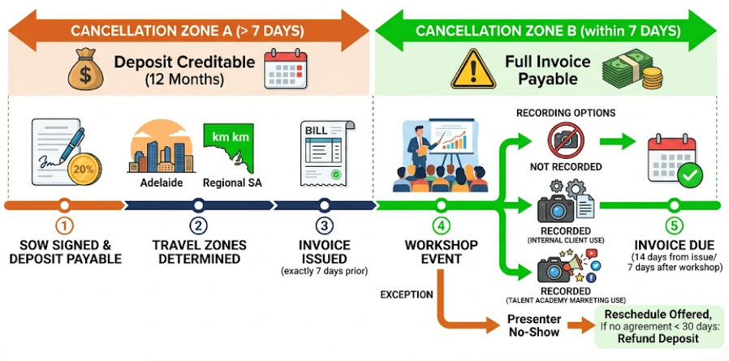
Client Details
- Client Legal Name: [Insert Client Name]
- Client ABN: [Insert ABN]
- Primary Contact Person: [Insert Name and Title]
- Contact Email & Phone: [Insert Email & Phone]

Workshop Details
- Workshop Title/Topic: [Insert Topic]
- Date(s) of Workshop: [Insert Date]
- Start & End Time: [Insert Times]
- Venue Address: [Insert Address]

Fees & Payment
- Total Service Fee: $[Insert Amount] (excl. GST)
- 20% Deposit Amount: $[Insert Amount] (excl. GST)
- Travel Allowance: $[Insert Amount or "Included for Adelaide Metro"]
- Speaker Portal Access: [Include Yes/No - 12 Months Access]

Recording & Privacy Consent
Please select ONE of the following options regarding the recording of the Workshop:
- [ ] Marketing & Internal Use: Talent Academy may record the workshop and use the footage for internal purposes, client training, and Talent Academy’s public marketing or promotional materials.
- [ ] Internal Use Only: Talent Academy may record the workshop, but the footage is strictly restricted to the Client’s internal use and Talent Academy’s private archives. No public marketing use is permitted.

Execution
By signing below, the Client agrees to this Statement of Work and the attached Master Services Agreement Terms and Conditions.

For the Client:
Signature: ___________________________
Name: _______________________________
Date: ________________________________

For Talent Academy:
Signature: ___________________________
Name: _______________________________
Date: ________________________________

MASTER SERVICES AGREEMENT TERMS AND CONDITIONS
1. Definitions and Interpretation
- Agreement: Means this Master Services Agreement (MSA) and the attached Statement of Work (SOW).
- Services: Means the workshop design, delivery, and related services specified in the SOW.
- Intellectual Property (IP): Means all slides, handouts, recordings, methodologies, and materials created or provided by Talent Academy.
- Speaker Portal: Means the proprietary software and online tools owned by Talent Academy.

2. Provision of Services
- Talent Academy will provide the Services with due care, skill, and professionalism.
- Talent Academy utilizes independent contractors to design and deliver the Services.
- Talent Academy reserves the right to substitute any scheduled presenter or contractor with another suitably qualified presenter at its sole discretion, without penalty or price reduction to the Client.

3. Fees and Payment Terms
- The Client must pay a non-refundable 20% deposit (as outlined in the SOW) to secure the booking.
- Talent Academy will issue the final invoice for the remaining 80% of the Service Fee and any applicable Travel Allowances seven (7) days prior to the scheduled Workshop date.
- All invoices are strictly payable within fourteen (14) days from the date of the invoice.

4. Cancellations and Rescheduling
- Client Cancellation more than 7 days prior: If the Client cancels or postpones the Workshop more than seven (7) days before the scheduled date, Talent Academy will retain the 20% deposit. This deposit will be converted into a Credit Note valid for twelve (12) months to be used toward future Talent Academy services.
- Client Cancellation within 7 days: If the Client cancels or postpones the Workshop within seven (7) days of the scheduled date, the Client is liable for 100% of the Total Service Fee. The invoice remains payable in full.
- Talent Academy Rescheduling: In the event of unforeseen circumstances (including sudden contractor illness or failure to attend), Talent Academy reserves the right to propose a rescheduled date for the Workshop. If the parties cannot mutually agree on a new date within thirty (30) days, the Client may terminate this Agreement and receive a full refund of the deposit. The Client agrees this refund is the sole remedy, and waives any right to claim further damages for the cancellation.

5. Travel Allowances
- Travel within the Adelaide Metropolitan Area is included in the standard Service Fee.
- Travel outside the Adelaide Metropolitan Area will incur a Travel Allowance as specified in the SOW. This will be calculated either as a flat Regional Zone fee or at the current Australian Taxation Office (ATO) standard cents-per-kilometer rate from the Adelaide CBD, as agreed in the SOW.

6. Intellectual Property
- Talent Academy (and its licensors) retains all ownership and Intellectual Property rights in the workshop materials, slides, handouts, and recordings.
- Upon full payment of the fees, Talent Academy grants the Client a non-exclusive, non-transferable, and royalty-free license to use the provided materials strictly for the Client's internal business and training purposes.

7. Speaker Portal Software
- Where access to the Speaker Portal is included, Talent Academy grants the Client a twelve (12) month non-transferable license to access the software, commencing on the date of the Workshop.

- Access does not renew automatically. Talent Academy will provide a renewal notice to the Client fourteen (14) days prior to the expiration of the twelve-month period.

8. Privacy and Consents
- The Client warrants that it has the necessary authority and has obtained all required consents from its employees, attendees, and representatives to be filmed, photographed, or recorded during the Workshop.
- Talent Academy will display a visual disclaimer during the Workshop notifying attendees of the recording.
- Talent Academy will strictly adhere to the recording usage restrictions selected by the Client via the checkbox on the SOW.

9. Liability and Indemnity
- To the maximum extent permitted by the Australian Consumer Law, Talent Academy’s total liability arising out of or in connection with the Services, whether in contract, tort (including negligence), or otherwise, is limited to the total Total Service Fees paid by the Client under the relevant SOW.
- Talent Academy will not be liable for any indirect, incidental, or consequential losses, including loss of profits or business interruption.

10. General
- Governing Law: This Agreement is governed by the laws of South Australia. The parties submit to the exclusive jurisdiction of the courts of South Australia.
- Severability: If any provision of this Agreement is held to be invalid or unenforceable, the remaining provisions will remain in full force and effect.
- Entire Agreement: This Agreement constitutes the entire understanding between the parties and supersedes all prior communications or agreements regarding the subject matter.

